The following plug-in allows for the following:

- Given the right credentials, providers can submit the their immunizations to CAIR (California Immunization Registry)
- Add immunizations and immunizations scheduling. This allows the user to program scheduled immunizations. Selecting the tool autopopulates the immunization screen which saves on repetitive typing.
- Add/Edit/Delete Immunizations schedules, manufacturers, and other details
- Track eligibility of VFC eligible immunizations (California residents) with the ability to include or exclude personal information.

Submitting electronically to CAIR

Step 1:

Go to Globals → IMM_REG and fill in your credentials. You will have to be registered with CAIR and they will have this information. This information is subject to change depending on the location of your practice and changes/improvements in the CAIR system. At the time of the creation of this document there are two WDSL URLs, one used for training (CATRN) and one used for production (CAPRD). Make sure that the WDSL has the ‘CATRN’ in the url until you have been approved by CAIR to submit production.

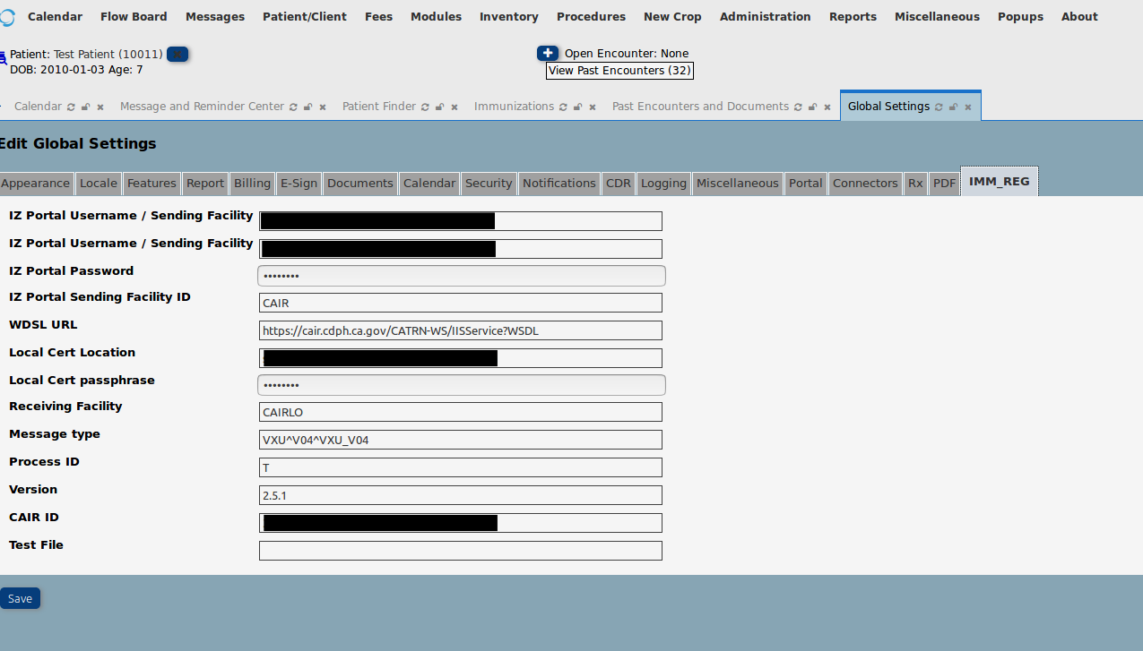
Illustration 1: Step 1: The CAIR credential screen

Step 2 (Optional) Enter in the Scheduling

Go to Administration → Immunizations → Edit Imm Scheduling
Select the age group and enter in the immunizations for that age group.

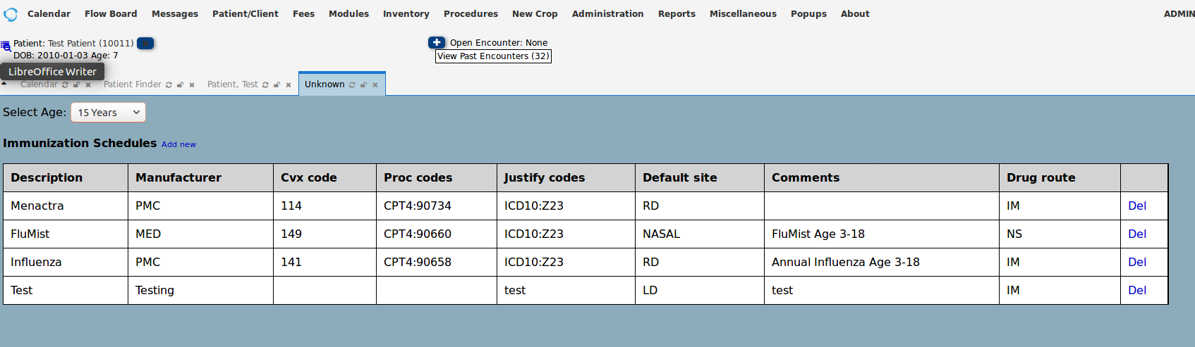
Step 3 – In the patient Demographic screen enter in the immunizations for the Patient. Click on (EDIT)
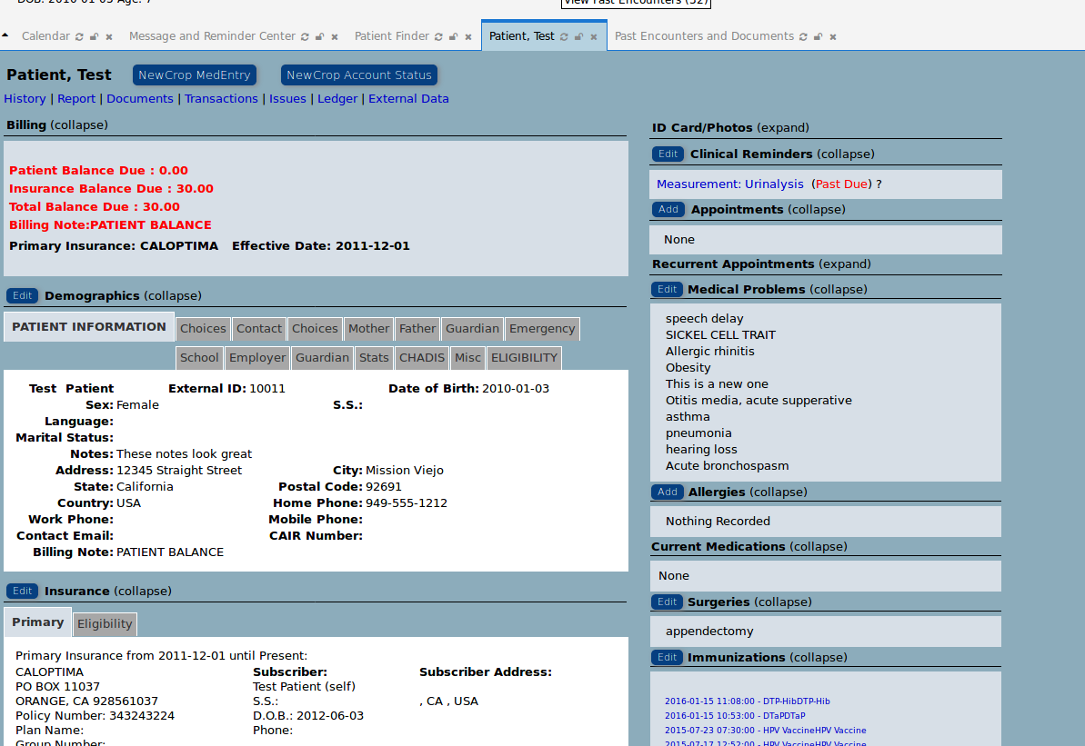

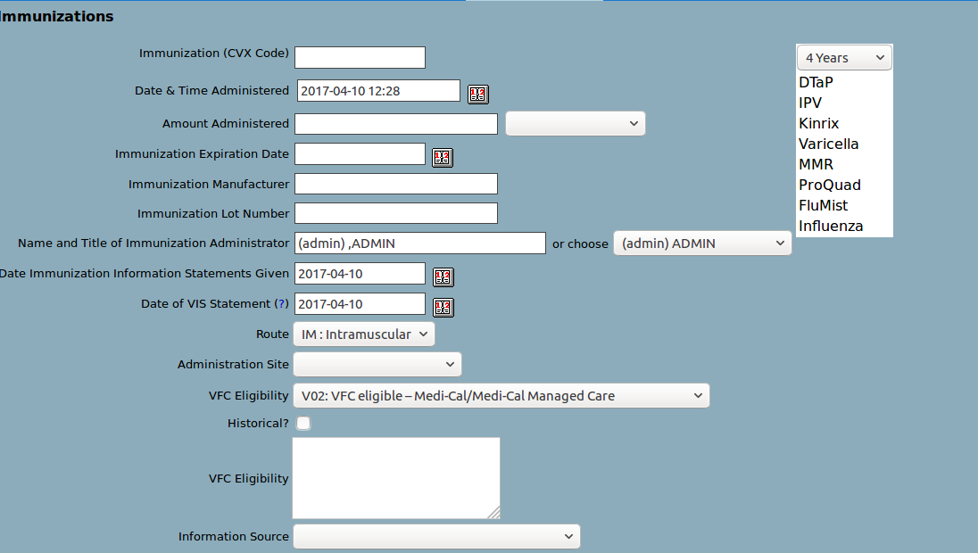
Enter in the immunization detailed info or use the schedule tool to auto-populate the necessary info

Step 4 – Sending the Immunizations to CAIR
Click on Reports→ Clients → Immunization Registry
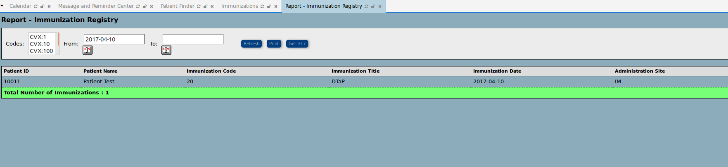
Enter in your dates. Click Refresh

Click on (GET HL7)
Review the HL7 file, click on Send.
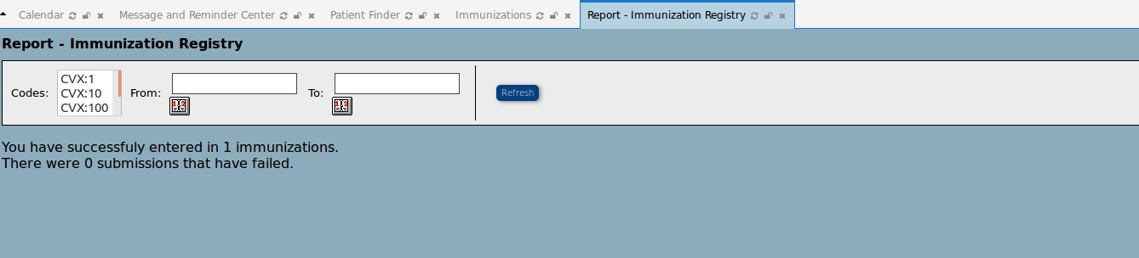

Getting the VFC report with names and without names.
Reports→Clinic→ VFC Reporting

